PARTH ASHRA
IT
ROLL NO.1

DELETING
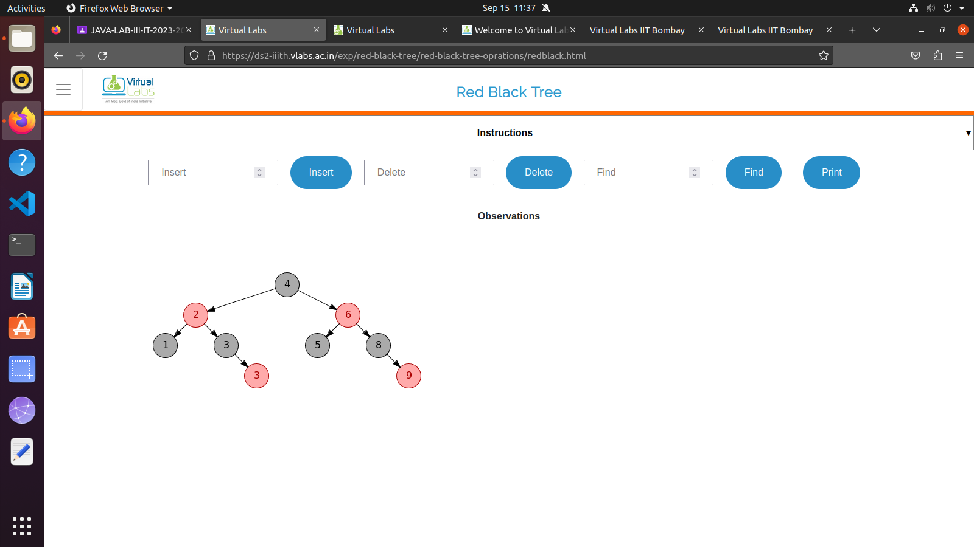
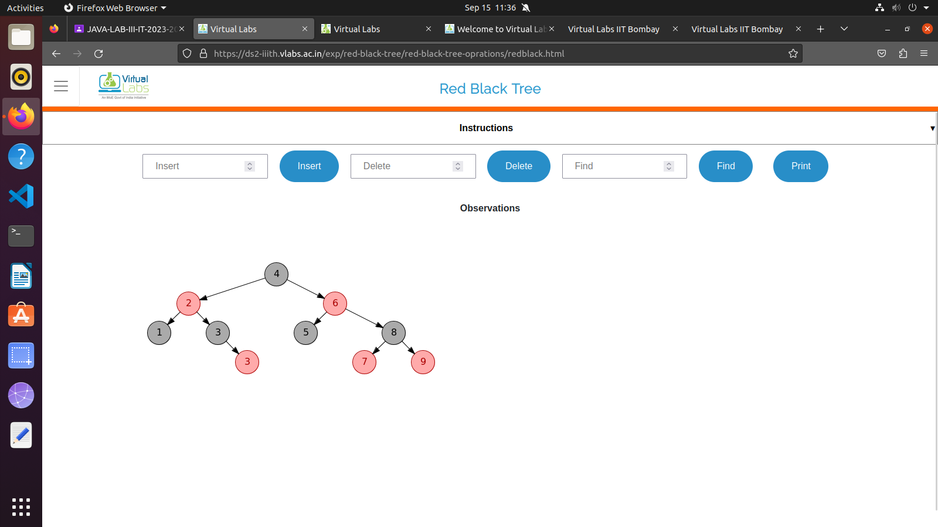

INSERTING

